

**LA GRANDEE INTERNATIONAL COLLEGE**

**Simalchaur, Pokhara, Nepal**

A Project Report

On

**“EClient”**

‘A perfect client management tool’

For Inter-College Software Competition

**Submitted to**

**LA GRANDEE EXPO** Committee

**LA GRANDEE International College**

**Submitted by:**

Prabhu Gurung

Pradeep Poudel

Pradip Dhakal

Date: 4th July, 2018

**Abstract:**

Every basic to complex work is possible and is done in computer worldwide. But according to our research, we found out the computer is still strange and complicated machine to many people in different ways.

The ideas is to make a program that will simplify our challenges that will occur under building and creating various project / work.

So we started this project as an small step which will turn into effectively method of user to collect, manipulate and use the data and information about client and their representative projects that save times, reduce more paper work, increase efficiency of data.

Contents

1. Introduction 1

2. Features: 2

2.1 Functional features: 2

2.1.1. Level of authorization: 2

2.1.2. Project Module: 2

2.1.3. Communication Module 3

2.1.4. Notification module: 3

2.1.5. Security module: 3

2.2 Non-Functional Features: 4

2.2.1. Security 4

2.2.2. User Friendly Interface 4

2.2.3. Validity of Data 4

3. Statement of Problem: 5

4. Project Objectives: 6

5. Management Plan 7

5.1. Feasibility Study: 7

5.2. Wireframe / Interface: 7

5.3. System Development: 7

5.4. System Testing: 7

5.5 System Implementation: 8

6. Er Diagram 9

7. System Flowchart Diagram 10

8. Data Flow Diagram 12

9. Implementation Areas and application: 13

10. Application Development 14

10.1 Application Development (Frontend): 14

10.1.1 Design and Markup 14

- Bootstrap: 14

10.2 Server Side (Back-end): 14

- MySQL: 15

- Gitlab: 15

11. Conclusion 16

12. References 17

# 1. Introduction

**“E-Client” (CMT)** is project with the concept of collecting project requirement of client in an efficient way as well as track the whole project progression during the development. The idea is to simplify a challenges that will occur in a company when they create and collect the final piece of information about project. CMT will have a characteristics of simple, secure & efficient way to collect information about project, and track entire project in a development phase, with a well clean Graphical User Interface (Dashboard, Tools).

Eclient is a web based application software which is SaaS model application targeted to users; may be any individual or company that handles multiple project simultaneously. This application will allow teachers & students, company manager & employers, project clients & it’s project development team. Simply, our web services will be hosted on server so ti can be used by all the people. This services will help us to finish the project effectively from beginning to end. It prioritize on creating effective partnership among the stakeholders related to a single project. For this, a list of all ongoing project will be made accessible to the user i.e. company or user. The project will be linked with multiple details and data. It will be about project initiator, assigned employee and the assigned activities. Communication is the major piece for any successful completion of a project that is why, a communication channel will be made available between the client and project initiator which may be audio/video as well as text communication.

# 2. Features:

The features of EClient are made available in two different formats i.e. Functional and Non-functional. These are described below:

## 2.1 Functional features:

### 2.1.1. Level of authorization:

There are different level of authorization for different user according to their role and involvement on a project. So, Eclient have created authorization as a: Administrative level, Client level and User level.

1. **Administrative level:**

**Eclient admins:** As being an application based on Saas model, Eclient will have admins that will handle different client who will be those Company taking a service from Eclient. This company will be the project initiator. This company related registration and request will all be handled by Eclient admins.

**Company admins:** Once the registration of a company has been approved then the company admin will be the able to administrate all the project, employees and project related activities and client users.

1. **User level:**

**Client User:** These are the users who will have less privilege than the admins. In Eclient, Client who are created and approved by Company admin are the major project stakeholder who initiate the project with the company. So, basically the Client user are the customer of Company.

### 2.1.2. Project Module:

The major facility of the Eclient software is to manage projects which will be by the Company admins. These are achieved via various management plans. These are:

1. **Project and module creation:**

Once a project is initiated by Company, Company can create a list of module which can be assigned to different employee. These modules will be created according to the client requirements. These module will be the major element in progress tracking of the project development and milestone creation.

1. **Employee assignment:**

A company may have a numbers of employee but may not be involved in all project of company. So, A company can assign its employee according to the need of the project. A project supervisor can be selected among them.

1. **Client Creation:**

A company can create multiple client users who are related to some project. They will be able to view the progress regarding their specific project, project modules, assigned employee, and communicate with them.

1. **Basic UI design:**

Simple UI design template can be created which will provide a prototype from the selected input. These will allow client to have instant look of the selected design to some extent.

1. **Module submit:**

As cloud being the modern trend for software developer, major developer or employee have some kind of cloud repository account to them. So, after the client have finished the module they can submit their work via link of their cloud account which the peer employee can view.

### 2.1.3. Communication Module

Communication module will allow the different stakeholder to have an efficient communication among themselves. The communication medium may be audio/video or chat. So, the level of communication among different stakeholder are :

1. **Eclient admin :**

Admin to admin

Admin to company admin

1. **Company:**

Company admin to company admin

Company admin to client.

1. **Client:**

Client to Client

Client to Company (related to only Company project)

### 2.1.4. Notification module:

Notification module will allow different stakeholder to get notified on different activities .

1. **via email:**

Email notification notify following activities:

* registration of company
* approved company
* to employee if any module is assigned
* forget password

1. **via phone message**

* approved company

1. **via dashboard notification:**

* to employee if any module is assigned
* assigned project supervisor employee

### 2.1.5. Security module:

Security is always a primary focus in any application and specially in a web-based application, it holds a major importance.

1. **Forget password:**

If any user forget their password, they can reset their password with password token sent via email.

1. **Remember Me:**

If user have tendency to forget their password, they can tick “Remember me” which will remember their password for next 7 days with encrypted cookie.

## 2.2 Non-Functional Features:

### 2.2.1. Security

Security measures are built into applications and have a sound application security routine minimize the likelihood that unauthorized code will be able to manipulate applications to access, steal, modify, or delete sensitive data.

Md5, salt, unique id are used as a primary security for database and ecrypted cookies and session handling are also being used for User information security.

### 2.2.2. User Friendly Interface

The interface that user will use are user friendly. The interfaces are designed with utmost importance so that the user will be able to utilize the application with minimum support.

### 2.2.3. Validity of Data

Validity is a measure of how well a test measures what it claims to measure. Different validation techniques are utilized in different input fields.

**2.2.4. Performance (Response time, throughput, utilization, static volumetric)**

**2.2.5. Capacity**

**2.2.6. Availability**

**2.2.7. Scalability**

**2.2.8. Manageability**

**2.2.9. Environmental**

**2.2.10. Usability**

**2.2.11. Interoperability**

# 3. Statement of Problem:

* Consumption of time due to traditional & manual in requirement gathering way.
* There is a lack of simplicity in others tools performing that task.
* Lack of maintenance of data in a proper way.
* Missing a small (micro) task that has a crucial advantage while project development.
* Data and information are important things to client so lack of assurance and misuse of data by software are largely seen.
* It consumes time on paper based work while project handler copy the entire requirement.
* Difficult in analyzing and tracking the individual project module.

# 4. Project Objectives:

* Able to create wide varieties of projects.
* Able to design / Interface of Project.
* Features to handle users/ client details.
* Track Progress and status of project.
* To Communicate and collaborate between client and team member.
* More GUI friendly (Dashboard, Tools, Steps)
* To reduce difficulty while initiating project.

# 5. Management Plan

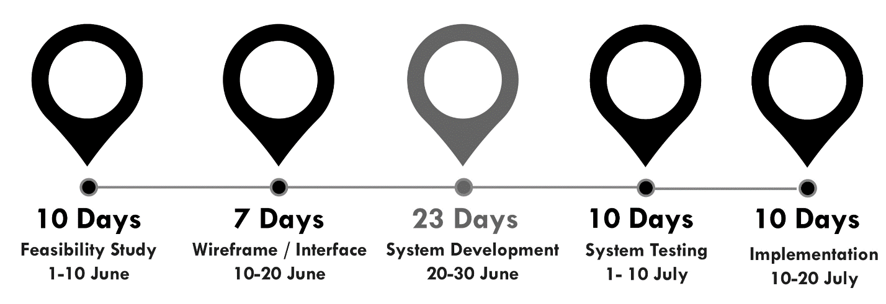*Fig: Fig 4.1: Waterfall Module*

The detail operation that was involved during this project is listed below:

5.1. Feasibility Study:  
 We check this concept of creating project in practicality by whether it can be made with certain time frame, resources, skills etc. It goes okay on all of the assessment that we have listed as feasibility study.

5.2. Wireframe / Interface:  
 After confirming the feasibility study we move on to Wireframing i.e. as we all know building a wireframe visual guide that represents the skeletal framework of a website with the purpose of arranging elements to best accomplish a particular purpose.

5.3. System Development:  
 System Design & System Development are the two main category that we have listed under system development. In System Design the Front-End Part of the web application was design with Bootstrap & Materialize CSS Framework along with many other reference site. And In System Development we have use PHP as a backend language and MySQL as a database language.

5.4. System Testing:  
With different test cases we have our system to ensure that it will function at it’s best way.  
Some test case and their result that we have done are:

|  |  |  |
| --- | --- | --- |
| **Test Case Name** | **Description** | **Test Results** |
| Authentication for:   1. User 2. Admin 3. Company | Login validity works quite well for User, Admin & Company. | Done |
| Data Insertion Validity Test | Validity with actual required data is done in this test case | Done |
| Responsiveness | Compatibility with mobile, tab, laptop and all the variety of screen sizes. | Done |
| Performance Test | Loading and performing certain task is quite good. | Half completed |
| Usability Test | With different available features this program can be widely use in different field. | Done |
| Database Test | The basic CRUD operation from database are done in this phase and which pass well too. | Done |
| Security Test | In terms of basic hacking and stealing data our program is secure with hashing, encryption and many other steps. | Done |
| Cookie/Session storage | Users session is handled and cookie can be save in their local machine with encryption. | Done |

## 5.5 System Implementation:

It is a online services so it need to execute internet application and since we have well test the system with different test cases, there was only small amount of technical issues otherwise the implementation phase also goes very well.

# 6. Er Diagram

We are trying to show the basic interrelated things of how data are structure in a way that it is integrated with database. This will be first phase ER Diagram so some model can be slightly change if required.

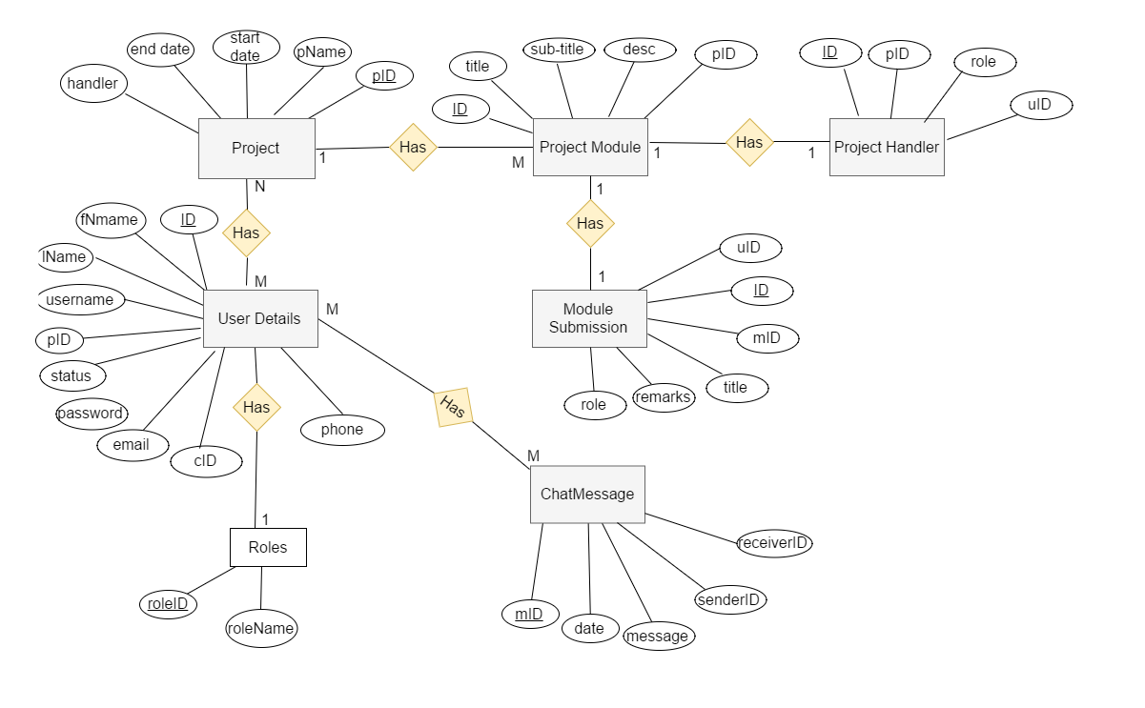

*Fig 6.1: Figure of ER Diagram*

# 7. System Flowchart Diagram

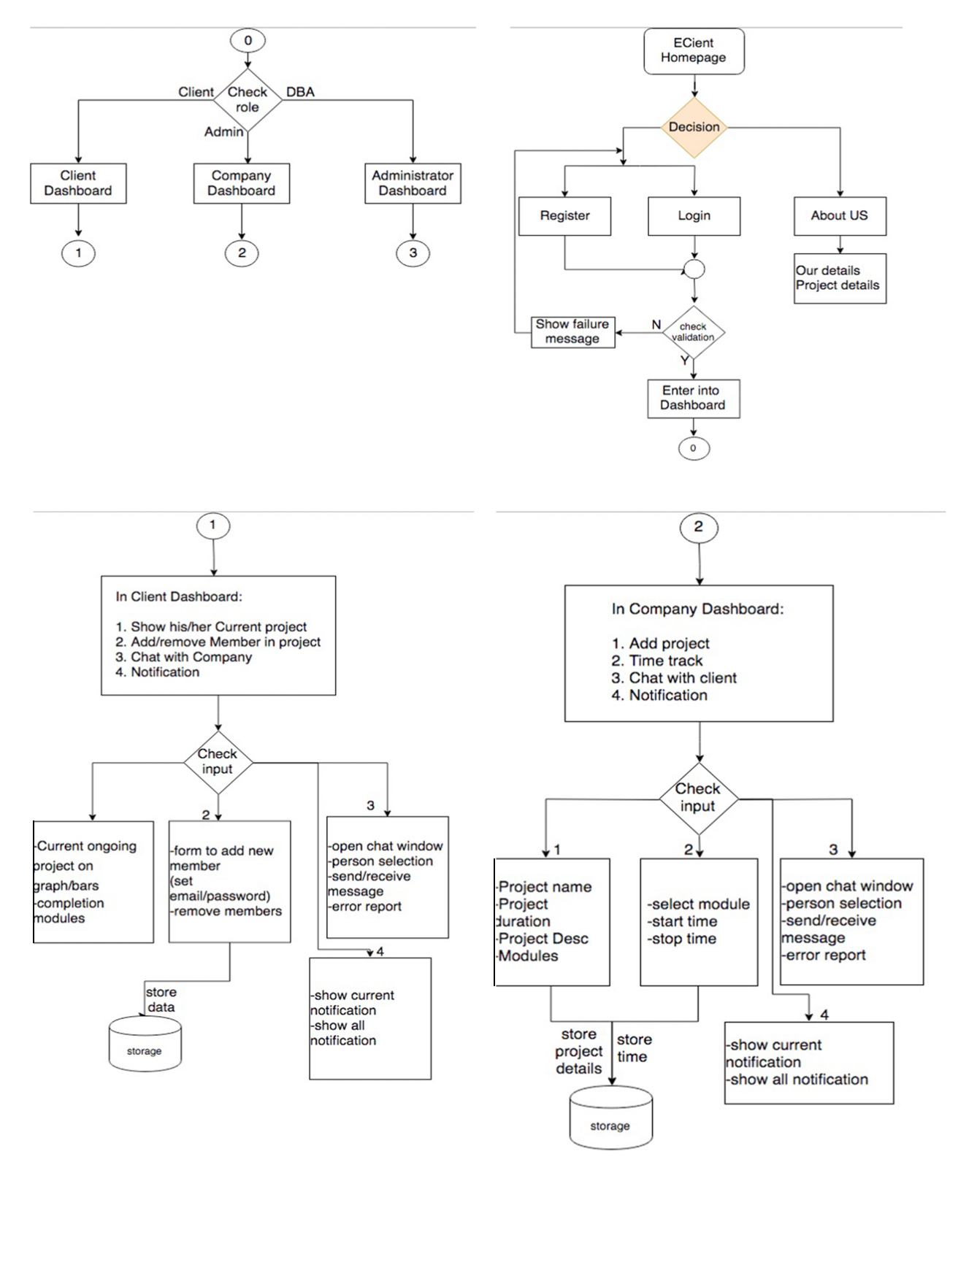

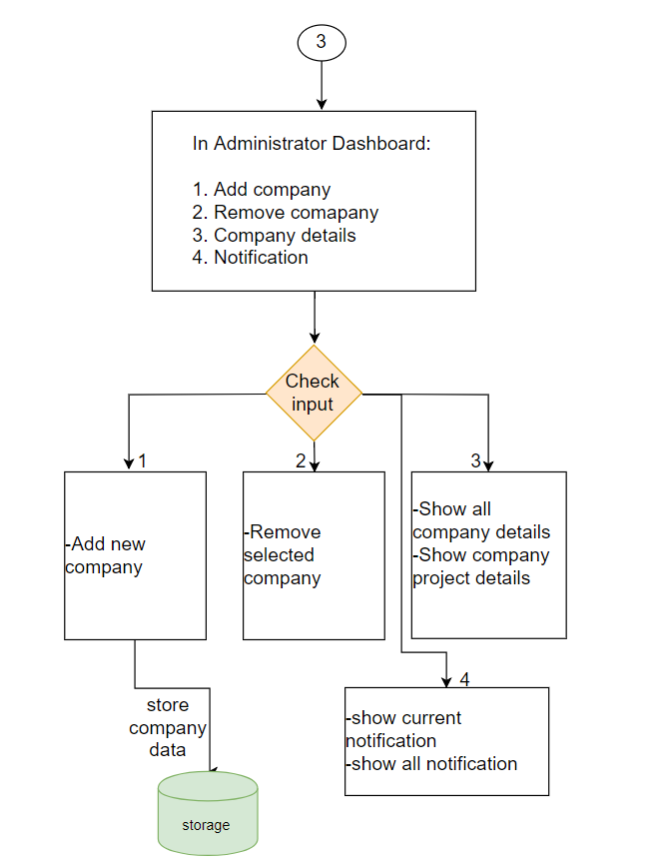

*Fig 7.1: Figure of Data Flow Diagram*

The first figure shows three different user types as client, company or administration which has their own role.

1. From Client role they can:
   1. See his/her current project.
   2. Add member of his/her project.
   3. Able to communicate with company employee.
   4. See Notification and message.
2. From Company role they can:
   1. Add/Remove project.
   2. Track the time consume by project.
   3. Communicate with client.
   4. See Notification and message.
3. From Administration role they can:
   1. Add/Remove company.
   2. Able to see company details.
   3. See notification and message.

# 8. Data Flow Diagram

In Below diagram we are showing the Level 0 (only the branch of module base work that we are choosing to do). And in second proposal defense, definitely we will show Level 1 (explaining and going deeper on Level 0 branch) and to show the flowchart diagram of it.

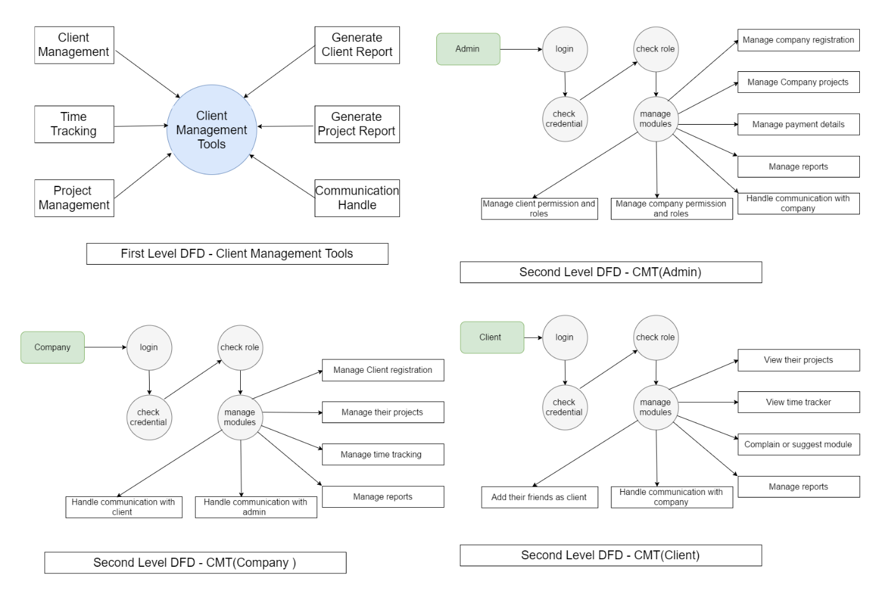

*Fig: Data Flow Diagram*

# 9. Implementation Areas and application:

Our project is made with such a concept that it is independent with any platform that means all kinds of project, business, company, organization and many other platform that has a client can use this program for their project initialization to finalization.

Some of the common field that can use our program are:

1. School / College / University.

-Teachers can easily assign project to their students and track that project assignment.

1. Company / Organization / Business.

-With different level of authorization different task are involved.

# 10. Application Development

## Application Development (Frontend):

10.1.1 Design and Markup: HTML5/CSS3/Bootstrap/SASS

Some of the tools and languages used as client side scripting are described as below:

# Bootstrap:

Bootstrap is the most popular HTML, CSS, and JavaScript framework for developing responsive, mobile-first websites.

We have used bootstrap for responsive features and development of web page in very elegant way.

**.**

## Server Side (Back-end):

* **Programming language :** Php
* **Development tool:** Apache server
* **Database :**  MySql
* **Testing Framework:** PHP unit
* **Source code versioning:** gitlab
* **Used SDK:** Tokbox

Some of the tools and languages used as server side scripting are described as below:

* **PHP: Hypertext Preprocessor** (or simply **PHP**) is a [server-side scripting](https://en.wikipedia.org/wiki/Server-side_scripting) language designed for [Web development](https://en.wikipedia.org/wiki/Web_development), but also used as a [general-purpose programming language](https://en.wikipedia.org/wiki/General-purpose_programming_language). It was originally created by [Rasmus Lerdorf](https://en.wikipedia.org/wiki/Rasmus_Lerdorf) in 1994, the PHP [reference implementation](https://en.wikipedia.org/wiki/Reference_implementation) is now produced by The PHP Group. PHP originally stood for Personal Home Page, but it now stands for the [recursive acronym](https://en.wikipedia.org/wiki/Recursive_acronym) PHP: Hypertext Preprocessor.

We have chosen core PHP as a server side scripting for the development of our project due to its simplicity and capability.

* **Apache Server:**

Apache is the most widely used web server software. Developed and maintained by Apache Software Foundation, Apache is an open source software available for free. It runs on 67% of all webservers in the world. It is fast, reliable, and secure. It can be highly customized to meet the needs of many different environments by using extensions and modules.

We have used Xampp to simulate Apache server for testing purpose on LAN, WAN.

# MySQL:

MySQL is an open-source relational database management system. Its name is a combination of "My", the name of co-founder Michael Widenius's daughter, and "SQL", the abbreviation for Structured Query Language. The MySQL development project has made its source code available under the terms of the GNU General Public License, as well as under a variety of proprietary agreements.

We have used MYSQL as relational database management system.

* **PHP UNIT:**  
  PHP Unit is a [unit testing](https://en.wikipedia.org/wiki/Unit_testing) [framework](https://en.wikipedia.org/wiki/Software_framework) for the [PHP programming language](https://en.wikipedia.org/wiki/PHP). It is an instance of the [xUnit](https://en.wikipedia.org/wiki/XUnit) architecture for unit testing frameworks that originated with [SUnit](https://en.wikipedia.org/wiki/SUnit) and became popular with [JUnit](https://en.wikipedia.org/wiki/JUnit). PHP Unit was created by Sebastian Bergmann and its development is hosted on [GitHub](https://en.wikipedia.org/wiki/GitHub).

# Gitlab:

GitLab is a web-based Git-repository manager with wiki and issue-tracking features, using an open-source license, developed by GitLab Inc.

GitLab is great way to manage git repositories on centralized server. GitLab gives you complete control over your repositories or projects and allows you to decide whether they are public or private for free.

We have used Gitlab as a version control application for our project development.

* **Tokbox Sdk:**

TokBox is the leading cloud platform for adding live video, voice & messaging to our websites and mobile apps. They integrate with real-time communications into products should be simple, whether you’re developing an app for one-to-one calls or for complex large-scale broadcasts.

We have used Tokbox Sdk for video & audio communication.

# 11. **Conclusion**

We have found many difficulties and problems during the time period of our project development. Main motive was to remove many problem which occur in paper based work. We have finished our requirement for first phase in time but our future enhancement are much bigger than the project it is now. It is supposed to be used by almost any business companies to make their work better. It can maximize efficiency with almost all necessary tool to gather information about client and work. It provide a facility to maintain a data in a proper way.

# 12. References

GitLab Inc. (n.d.). *gitlab*. Retrieved from gitlab.com/: https://about.gitlab.com/

Mr. Sunil Pandey. (n.d.). requirement and feasibiltiy analysis. ( Pradeep Dhakal, Interviewer)

Mark Otto, Jacob Thornton. (n.d.). *bootstrap*. Retrieved from bootstrap: https://getbootstrap.com/docs/4.0/getting-started/introduction/

Nonfunctional-Requirement. (2018). Retrieved July 3, 2018, from requirementsquest.com: https://requirementsquest.com/wpcontent/uploads/2017/01/Nonfunctional-Requirement-EXAMPLES.pdf

https://stackoverflow.com/

https://materializecss.com/

http://php.net/manual/